**Chef’s Creek Oysters**

Location: Baynes Sound, east Vancouver Island, British Columbia

Size: Up to 3”

Flavor: Chef’s Creek Oysters have a shallow cup with ivory meat and a dark black mantle. They are creamy with a high brininess and sweet flavor.

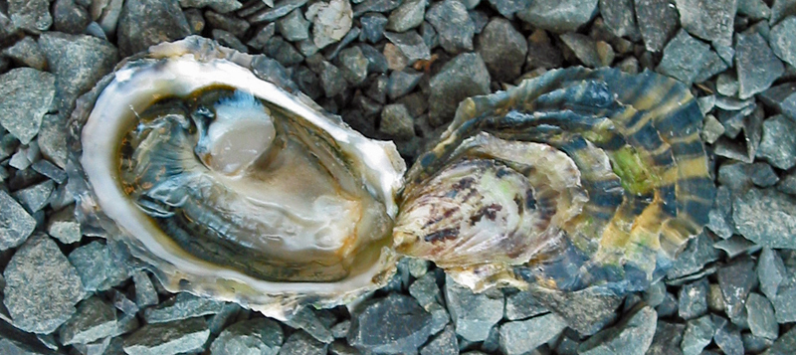

**Kusshi Oysters**

Location: Deep Bay, Vancouver Island, British Columbia

Size: Up to 2 ½”

Flavor: Kusshi Oysters have deep cups with meaty flesh and a very clean, delicate flavor.

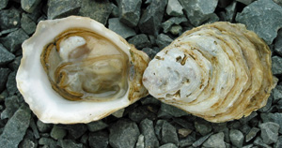

**Komo Gway Oysters**

Location: Baynes Sound, E. Vancouver Island, British Columbia

Size: Up to 4”

Flavor: Komo Gway Oysters are firm fleshed with a refreshing briny taste and vibrantly colored mantel. They have a subtle note of cucumber & a slightly sweet finish.

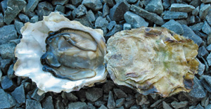

**Kumamoto Oysters**

Location: South Puget Sound, WA -or- Humbolt Bay, CA

Size: 2” - 3”

Flavor: Kumamoto Oysters are deep-cupped with petite meats, have a mild brininess, sweet flavor and a honeydew finish. They are a favorite for beginning oyster eaters and connoisseurs.

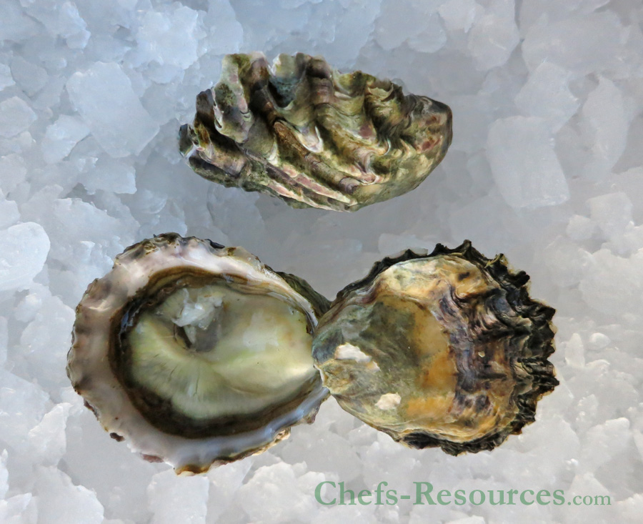

**Royal Miyagi Oysters**

Location: Sunshine Coast, Strait of Georgia, British Columbia

Size: up to 4”

Flavor: Royal Miyagi Oysters have smooth textured meats with a mild brininess and kiwi-like finish.

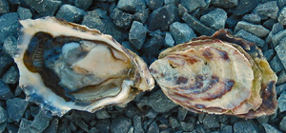

**Malpeque Oysters**

Location: Malpeque Bay, PEI

Size: 3” - 4”

Flavor: Moderate brine with a meaty bite and a quick, clean finish

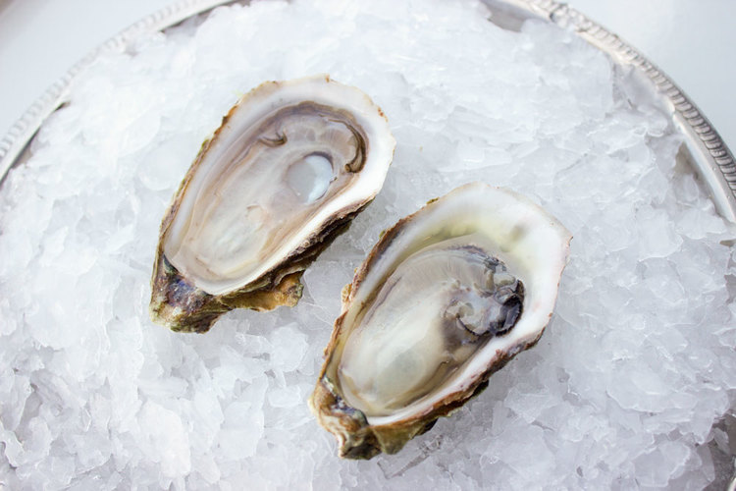

**Raspberry Point Oysters**

Location: Prince Edward Island National Park, Prince Edward Island, Canada

Size: Up to 3”

Flavor: Raspberry Point Oysters have a high brininess, clean flavor with a sweet finish

